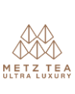
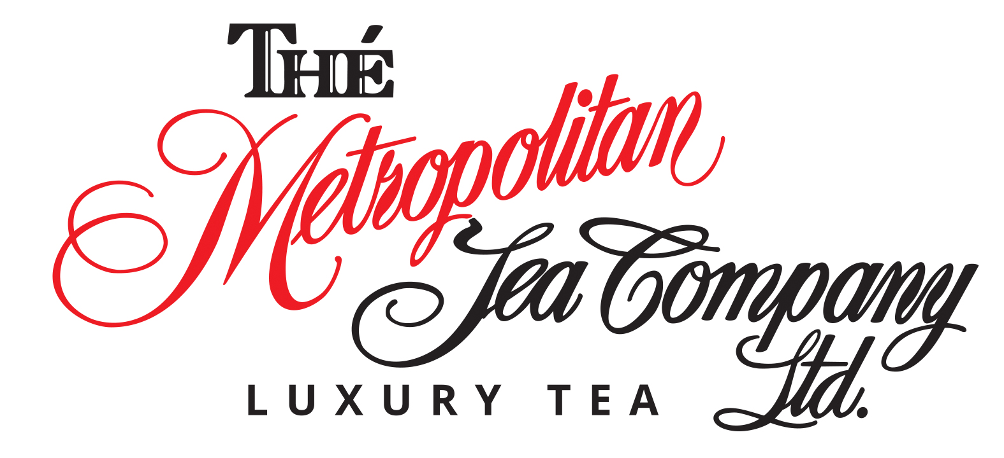

Use the METZ TEA TRAINING GUIDE to complete the following test
Refer to the TEA PROFILES section for questions pertaining to cup descriptions
Should you require any assistance (or hints) please reach out to sales@metrotea.com

Name: Click here to enter text.
Hotel Property: Click here to enter text.

- What company manufactures Metz Tea and where are they based?
Click here to enter text.

- What are the four main tea varieties and what plant do they come from?
Click here to enter text.

- What is the Banana Analogy as it pertains to tea?
Click here to enter text.

- What are the two basic leaf styles of black tea? What is the major difference between the two?
Click here to enter text.

- Name four Metz black teas and provide a brief cup description for each.
Click here to enter text.

- List some characteristics and/or serving recommendations for black tea
Click here to enter text.

- What method(s) are used to halt the oxidation process of green tea?
Click here to enter text.

- List two Metz green teas and provide a brief cup description for each
Click here to enter text.

- Green tea contains more caffeine than black tea
☐True ☐False

- Green tea is best served as-is, with no milk or sugar
☐True ☐False

- List two Metz herbal teas and provide a cup description for each
Click here to enter text.

- Herb + Fruit teas are caffeine - free
☐True ☐False

- South Africa is the only place where Rooibos is grown.
☐True ☐False

- What is the function of Cucumber Melon?

Click here to enter text.

- What year was the tea bag said to have been created?
☐2737 BC ☐1657 ☐1839 ☐1908

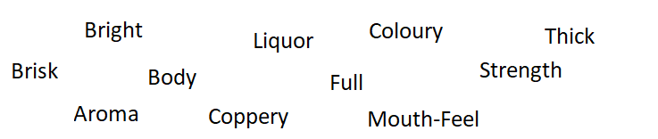
- Match the words with the correct definitions.

Click here to enter text. | Brewed tea – the liquid in the cup
Click here to enter text. | the right balance of colour and strength.
Click here to enter text. | The smell or scent denoting the inherent character one should expect from a brewed tea
Click here to enter text. | A cup with deep colour indicative of strength.
Click here to enter text. | A lively visual appearance. This is what we look for in the cup liquor (brewed tea).
Click here to enter text. | A tea with a full, well-balanced astringency that satisfies all the taste receptors in the mouth.
Click here to enter text. | The brightly, copper coloured leaves of black tea. Coppery colour is indicative of well-manufactured tea.
Click here to enter text. | The substance of the cup. (Typically the result of brewing time. The longer the brew, the stronger the cup).
Click here to enter text. | Tea that exhibits fullness and strength
Click here to enter text. | Liquor with excellent colour and strength.
Click here to enter text. | A bright, lively character that surprises the taste buds. Indicative of well-made tea.

- List ten growing regions used in Metz teas
Click here to enter text.

- Describe what to look for in Sri Lanka (Ceylon) black tea, and name a Metz tea that contains Sri Lanka
Click here to enter text.

- Which country is considered the birthplace of tea?
☐India ☐England ☐Japan ☐China

- Describe what to look for in China green tea, and name a Metz tea that contains China
Click here to enter text.

- Describe what to look for in Kenya black tea, and name a Metz tea that contains Kenya
Click here to enter text.

- Describe what to look for in Assam black tea, and name a Metz tea that contains Assam
Click here to enter text.

- Describe what to look for in Japanese green tea, and name a Metz tea that contains Japan
Click here to enter text.

- Where can the world’s best Camomile be found? What makes it so good?
Click here to enter text.

- Where is Metz peppermint grown? What makes it so good?
Click here to enter text.

- Describe what to look for in Rooibos, and name a Metz tea that contains Rooibos
Click here to enter text.

- “Lush Burgundy depths, full and brisk.” Describes which tea?
☐Grand Breakfast ☐ Salted Caramel
☐Cream Earl Grey ☐Orange Pekoe
- Which green teas contain Natural Flavouring?
Click here to enter text.

- Which one of the teas below is naturally caffeine free and its ingredients list includes Apple, Hibiscus, Rosehip, Orange, Strawberry, Calendula, Cornflowers?
☐Mediterranean Blue ☐Berry Berry ☐Ayurvedic Balance
☐Strawberry Kiwi ☐ Angel Falls Mist

- List the Country of Origins that the ingredients in Bourbon St. Vanilla are from.
Click here to enter text.

- Mediterranean Blue is described as “Tuscany summer in a cup”. What type of tea is it?
☐Black Tea ☐Functional Tea ☐Herb + Fruit ☐Green Tea

- What are the recommended brewing times for Metz iced teas? Check all that apply.
☐4-5 minutes ☐2-3 minutes ☐6-7 minutes ☐5-10 minutes

- Serving suggestions – for each of the following categories please check which condiments should be served.
Black Tea
☐Milk ☐Sugar/ Honey ☐Lemon
Green Tea
☐Milk ☐Sugar/ Honey ☐Lemon
Herb & Fruit Tea
☐Milk ☐Sugar/ Honey ☐Lemon
Herbal Tea
☐Milk ☐Sugar/ Honey ☐Lemon
Functional Tea
☒Milk ☐Sugar/ Honey ☐Lemon
Rooibos Tea
☐Milk ☐Sugar/ Honey ☐Lemon

- List at least five things that make Metz Luxury teabags unique.
Click here to enter text.

- How many enveloped tea bags are in one box of Metz Luxury tea bags?
Click here to enter text.

- How many Metz teabags would you use for a 14oz teapot?
Click here to enter text.

- What is the WORST thing you can do when preparing tea for guests?
☐Make it too strong ☐Make it too weak

- When preparing iced black teas, the liquid may turn cloudy. This is normal, and a sign of high-quality tea.
☐True ☐False

- The longer you brew tea, the more antioxidants are released.
☐True ☐False

- What is the recommended steeping time for Herb + Fruit teas?
☐2-3 minutes ☐4-5 minutes ☐5-10 minutes

- How many liters does one Metz Iced Tea Bag make?
Click here to enter text.

- The best way to sweeten iced tea is with granulated sugar.
☐True ☐False

- You should keep separate serving vessels for coffee and tea to ensure there is no flavor transfer.
☐True ☐False

- You can use both glass and acrylic vessels to prepare iced tea.
☐True ☐False

- Why do we recommend one-time use for Metz Pyramid tea bags?
Click here to enter text.

- Which of the following is NOT a true statement about Metz teas
☐Made in a solar powered facility
☐Grown on family farms
☐Plant based, no plastic
☐ Fairtrade certified

- Metropolitan Luxury Tea Group became the first North American organization to sign on with the Ethical Tea Partnership.
☐True ☐False

- Refer to the Allergens section of the Tea Sommelier Portal and identify which allergens are present in the same manufacturing factory
Click here to enter text.

- Refer to the Metz Products section and list the 4 different product categories
Click here to enter text.
- Refer to the Nutritional section and identify how many calories per one cup of Bourbon Street Vanilla
Click here to enter text.

- Refer to the Tea Profiles section and identify the cup characteristics of Cochin Masala Chai
Click here to enter text.

- You have a guest with children who want to enjoy a High Tea. What teas would you suggest for the children and why?
Click here to enter text.

- A guest is looking for a tea to drink before bed, which would you suggest and why?
Click here to enter text.

- A guest has just had a delicious and filling dinner. They would like a nice cup of tea to help with digestion, which would you suggest and why?
Click here to enter text.

- Which is your favourite Metz tea and why?
Click here to enter text.

